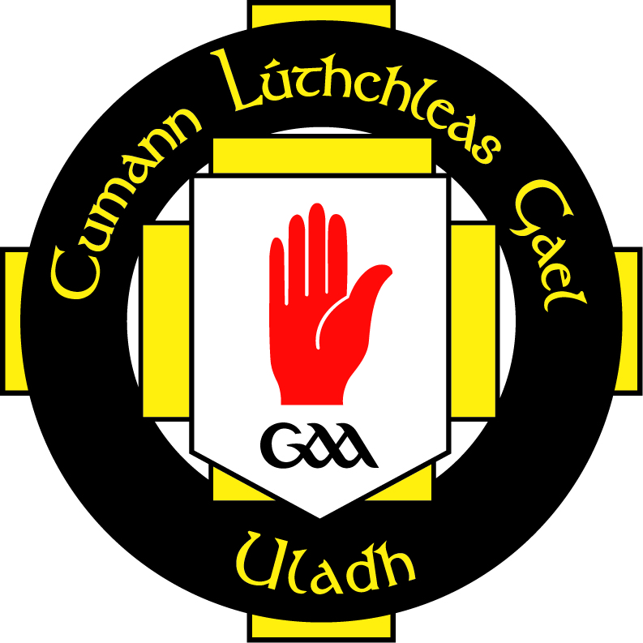
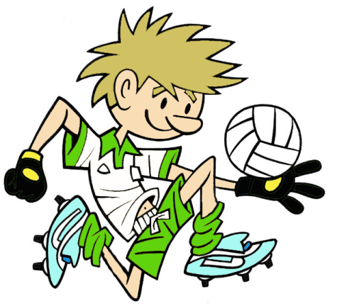


RULES – HOW TO PLAY
Mark out circle 4m radius with cones as shown

Mark out 4 other circles 4m radius with domes as shown

Uneven teams 6 v 3

Team of 6 are outside the circle

Other 3 players are inside circle

Players inside circle, clear the circle by using the hook kick at targets

Outside players must retrieve balls and roll them back into circle

Reverse the roles after a set time

TARGET GAME: Game 6
GAME: Clear the Circle

FOCUS
- To develop the players ability to look for free space and hook kick the ball into that area

HARDER
- Outside team must kick the balls back into circle from a set distance e.g. 10/20m
- Set up identical circle 4 x 20m away and place even teams in each circle, aim to kick ball into each other’s circle
- Use non-preferred foot
- Place defenders inside circle to block kicks
EASIER
- More players inside circle
- Bigger circles to punt to

COACHING POINTS
HEAD
- Scan for free space to kick into
- Eyes on ball when punting and keep head down to well after the kick
HANDS
- Start with shoulder towards target
- Release ball from same hand to same foot for the hook kick
- Extend opposite arm away and slightly behind body for balance
FEET
- Step forward with non-kicking foot
- Kick with the inside of the foot
- Follow through with kicking leg which moves across the body and towards the target
EQUIPMENT

- Cones

- Domes

- Footballs

Copyright Ulster Council GAA 2009

